|  |  |
| --- | --- |
| A picture of a winding road and trees  Reliability of Solar Energy  in  South East Asia | Link:  http  Team Name:  Responder  Student Names & IDs:  Siew Joe Kane 103130764  Foo Chi Ping 103487570  Year and Semester:  2, Semester 4  Word Count:  2000+ |
|  |  |

Table of Contents

1 Introduction 2

1.1 Background and Motivation 2

1.2 Visualisation Purpose 2

1.3 Project Schedule 2

2 Data 3

2.1 Data Source 3

2.2 Data Processing 4

3 Requirements 4

3.1 Must-Have Features 4

3.2 Optional Features 4

4 Visualisation Design 5

5 Validation [optional - Bonus Points] 10

6 Conclusion 11

References 11

# 1 Introduction

## 1.1 Background and Motivation

**Target Audience**

The users who will benefit from this visualization are energy enthusiasts, climate scientists, climate activists and businesspeople from the energy sector.

**Potential tasks**

The audience of this visualization will want to observe which Southeast Asia country has a better prospect of utilizing and generating a healthy amount of energy from solar compared to other alternatives in the space of renewable energy.

**Importance of the project**

The importance of this visualization project is to give insight to whether solar energy is a viable source of energy and should remain as an option for renewable energy.

## 1.2 Visualisation Purpose

**Questions users will be able to answer with your visualisation**

The visualization project aims to answer the question whether solar energy is a reliable renewable energy source in south-eastern region of Asia. The data could originate from government websites and publicly available data published by energy corporations.

List of possible benefits of the completed visualisation:

1. Figure out which south-east Asian country has the best prospects in harnessing the potential of solar energy.
2. Figure out if solar energy is a viable renewable energy source.

## 1.3 Project Schedule

Make sure that you plan your work so that you can avoid a big rush right before the final project deadline. Write this in terms of weekly deadlines.

|  |  |  |  |  |  |
| --- | --- | --- | --- | --- | --- |
| Task Mode | Task Name | Duration | Start | Finish | Predecessors |
| **Manually Scheduled** | **Project Start.** | **38 days** | **Mon 22/08/22** | **Wed 22/10/12** |  |
| Auto Scheduled | Decide on topic. | 12 days | Fri 22/09/09 | Mon 22/09/26 |  |
| Auto Scheduled | Search for data. Preferrably in CSV format. | 12 days | Tue 22/09/27 | Wed 22/10/12 | 2 |
| **Manually Scheduled** | **First Standup** | **35 days** | **Thu 22/10/13** | **Wed 22/11/30** | **1** |
| Auto Scheduled | Find data. | 3 days | Thu 22/10/13 | Mon 22/10/17 |  |
| Auto Scheduled | Design low fidelity designs. | 5 days | Tue 22/10/18 | Mon 22/10/24 | 5 |
| Auto Scheduled | Draft first website design. | 5 days | Tue 22/10/25 | Mon 22/10/31 | 6 |
| Auto Scheduled | First draft process book. | 0.5 days | Tue 22/11/01 | Tue 22/11/01 | 7 |
| **Manually Scheduled** | **Second Standup** | **5 days** | **Tue 22/11/01** | **Mon 22/11/07** | **4** |
| Auto Scheduled | Research other countries. | 1 day | Tue 22/11/01 | Tue 22/11/01 |  |
| Auto Scheduled | Implement new charts. | 3 days | Wed 22/11/02 | Fri 22/11/04 | 10 |
| Auto Scheduled | Make progress on process book. | 0.5 days | Mon 22/11/07 | Mon 22/11/07 | 11 |
| **Manually Scheduled** | **Third Standup** | **5 days** | **Tue 22/11/08** | **Mon 22/11/14** | **9** |
| Auto Scheduled | Finalize data visualization. | 5 days | Tue 22/11/08 | Mon 22/11/14 |  |
| Auto Scheduled | Last Standup | 1 day | Tue 22/11/22 | Tue 22/11/22 | 13 |

# 2 Data

## 2.1 Data Source

**From where and how are you collecting your data?**

Data collected for the visualization project are from publicly available government websites and published research data published by energy corporations.

The data used originate from the following sources:

1. data.gov.my
2. data.gov.sg
3. data.world
4. <https://www.aiddata.org/>
5. https://worldpopulationreview.com/

**What type of data set is it (e.g., table, network, field)?**

The data used are in the form of CSV (Comma Separated Values) format. Although, the data available online are mainly in Excel formats with styled headers and body to describe the purpose of the research and data, therefore, some data cleaning and understanding were necessary.

**Attributes in data set and type of data are the values (i.e., categorial, ordinal, interval, ratio/quantitative)**

Chart 1: Year, Interval Data

Chart 2: Year, Interval Data

Chart 3: Countries, Categorical Data

Chart 4: Region, Qualitative/Nominal Data

**Data in the set that will not be included in your visualisation**

NOTE: Make sure that the data can be used to answer the questions outlined in Section 1.2.

Data will not be included in visualisation will be < insert comments >

## 2.2 Data Processing

**Do you expect to do substantial data cleanup?**

Data cleaning is expected due to the heavily formatted Excel sheet available online. Although, with data sets available in CSV format out of the box, then this step is unnecessary.

**What quantities do you plan to derive from your data?**

The whole entry available within a dataset will be used for processing. If not, a data cleaning process will be carried out to narrow down the dataset for easy data processing.

**How will data processing be implemented?**

With invalid data, those entries will be filtered out in JavaScript when reading data. Null or missing values will also be filtered out rather than giving them average or ignored.

**Will you be deriving any variables?**

**Describe clean-up process that was implemented.**

**Explanation and calculation of derived variables.**

There are no additional calculations required since all measurements are in metric measurements and not imperial measurements since the data gathered do not originate from the US.

# 3 Requirements

## 3.1 Must-Have Features

**These are features without which you would consider your project to be a failure. Were you able to deliver all the promised features? If not, explain why.**

* A fully hosted and functioning website is a must-have features in this project.
* Each visualisation charts must contain at least one interactive element.

## 3.2 Optional Features

**Those features which you consider would be nice to have, but not critical.**

* Account Management Feature
  + login and signout function nice to have to but not required.
  + Account management.
* Live data fetching from 3rd Party API.

**Were you able to deliver any of these extra features?**

No. Due to time constraint and scope of the project, the above mentioned features were not implemented.

The account management feature is nice to have, but not necessary to achieve the key outcome of the visualization project.

The implementation of real time 3rd party APIs is also nice to have which would make the charts update more dynamically but is not necessary.

# 4 Visualisation Design

**How will you display your data?**

A set of low fidelity design will be prepared before implement any coding development. The low fidelity design of website user interface and individual chart are sketched using draw.io; a web-based drawing tool and paint software from Microsoft. Each chart will be created from different dataset and included at least one interactive element such as mouse-over effect and interactive legend to filter and manipulate the data of the chart.

**Provide some general ideas that you have for the visualisation design. Include sketches of your design. Include at least 2-3 alternative ideas for your visualisation. Describe and justify your choice of visual encoding and idioms.**

**Sketches Screenshots (Website):**

First sketch is the interface design for the website. The content will be display only in one page. Project Title will be display on top area of the website as it showed a clear objective of the project to the users.

For content section, card view will be implemented to manage the content in more effective way. First card view consists of brief description regarding history of solar energy. Second card view will focus on displaying several charts in neat and clean position.

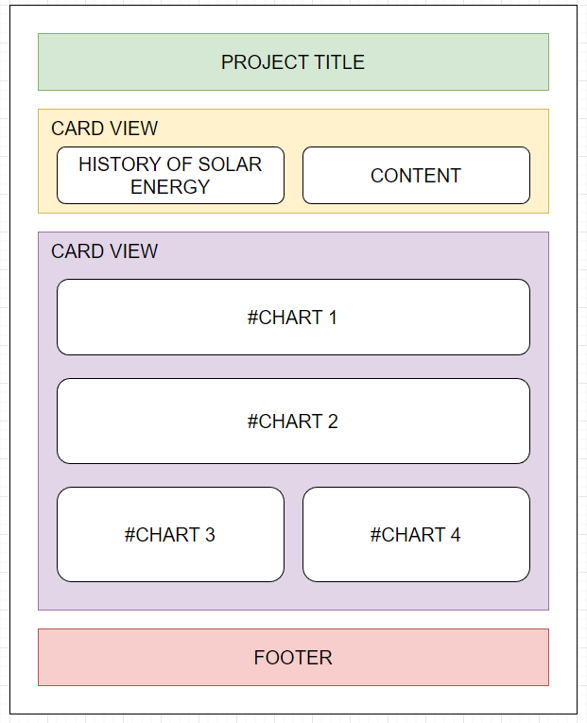

Figure 1

**Sketches Screenshots (Charts):**

First chart will show user about the consumption of renewable energy in Southeast Asia. The dataset used are continuous data across multiple year, line chart will be suitable to handle the data.

Sketch below showing data displaying in line chart format. X axis is renewable energy consumption in year and Y axis is percentage of total consumption in each country. The chart will arrange a set of interactive legends (Southeast Asia countries) for user to click and filter the countries whether to display or not display in the line chart.

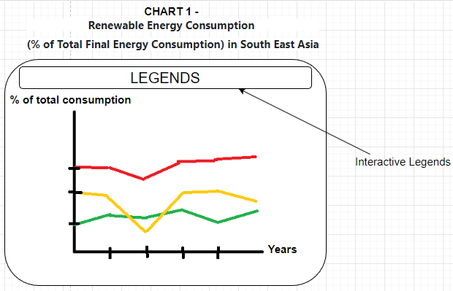

Figure 2

Second chart will show user about the percentage of total solar capacity in Southeast Asia. The dataset also provided continuous data across multiple year and line chart will be suitable to handle the data.

Sketch below showing data displaying in line chart. X axis is total solar capacity in year and Y axis is percentage of total capacity in each country. Unlike first chart, this line chart will equip with mouse-over effect to display detail information. On hover, the closest data point to the mouse cursor and its associated line series will be display the detail information.

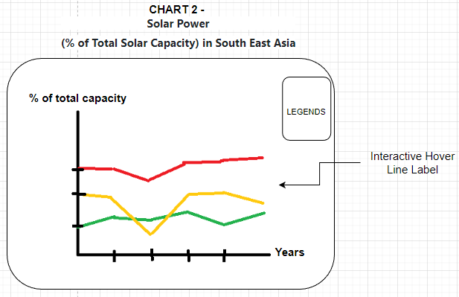

Figure 3

Third chart will show user about the renewable energy production in Singapore. The dataset found is categorical dataset across multiple year. Stacked bar chart is suitable in displaying the data.

Sketch below showing data in stacked bar chart. X axis is production of each renewable energy category in year and Y axis is total energy generation of stacked categories in percentage. This stacked bar chart will equip with mouse-over effect to display detail information. On hover, different total percentage of energy production will display when mouse cursor pointed to the specific colour sector.

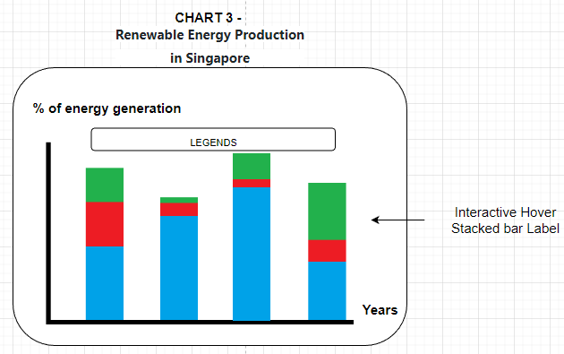

Figure 4

Fourth chart will show user about the Singapore solar PV installation in region. The dataset used contain the information of PV installation in region of Singapore. So, geo map graph will be suitable to display the data.

Sketch below showing geo map group with hover effect. Detail information will show in bottom right corner when mouse cursor pointed to specific region.

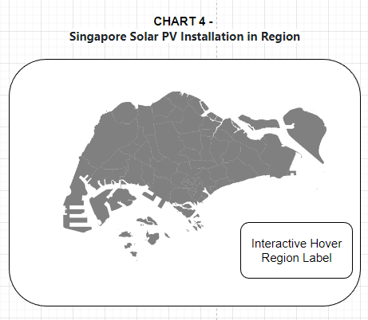

Figure 5

**Show the evolution of your design. How has it progressed? Justify the visualisation idioms you have chosen to represent your data.**

**Description (including screen shots) and explanation of final design.**

After the website and visualization chart created, the outputs served well and the objective of reliability of solar energy in Southeast Asia is clearly showed to the user. Hence, the first sketches of the website and contents will be the final design for the project.

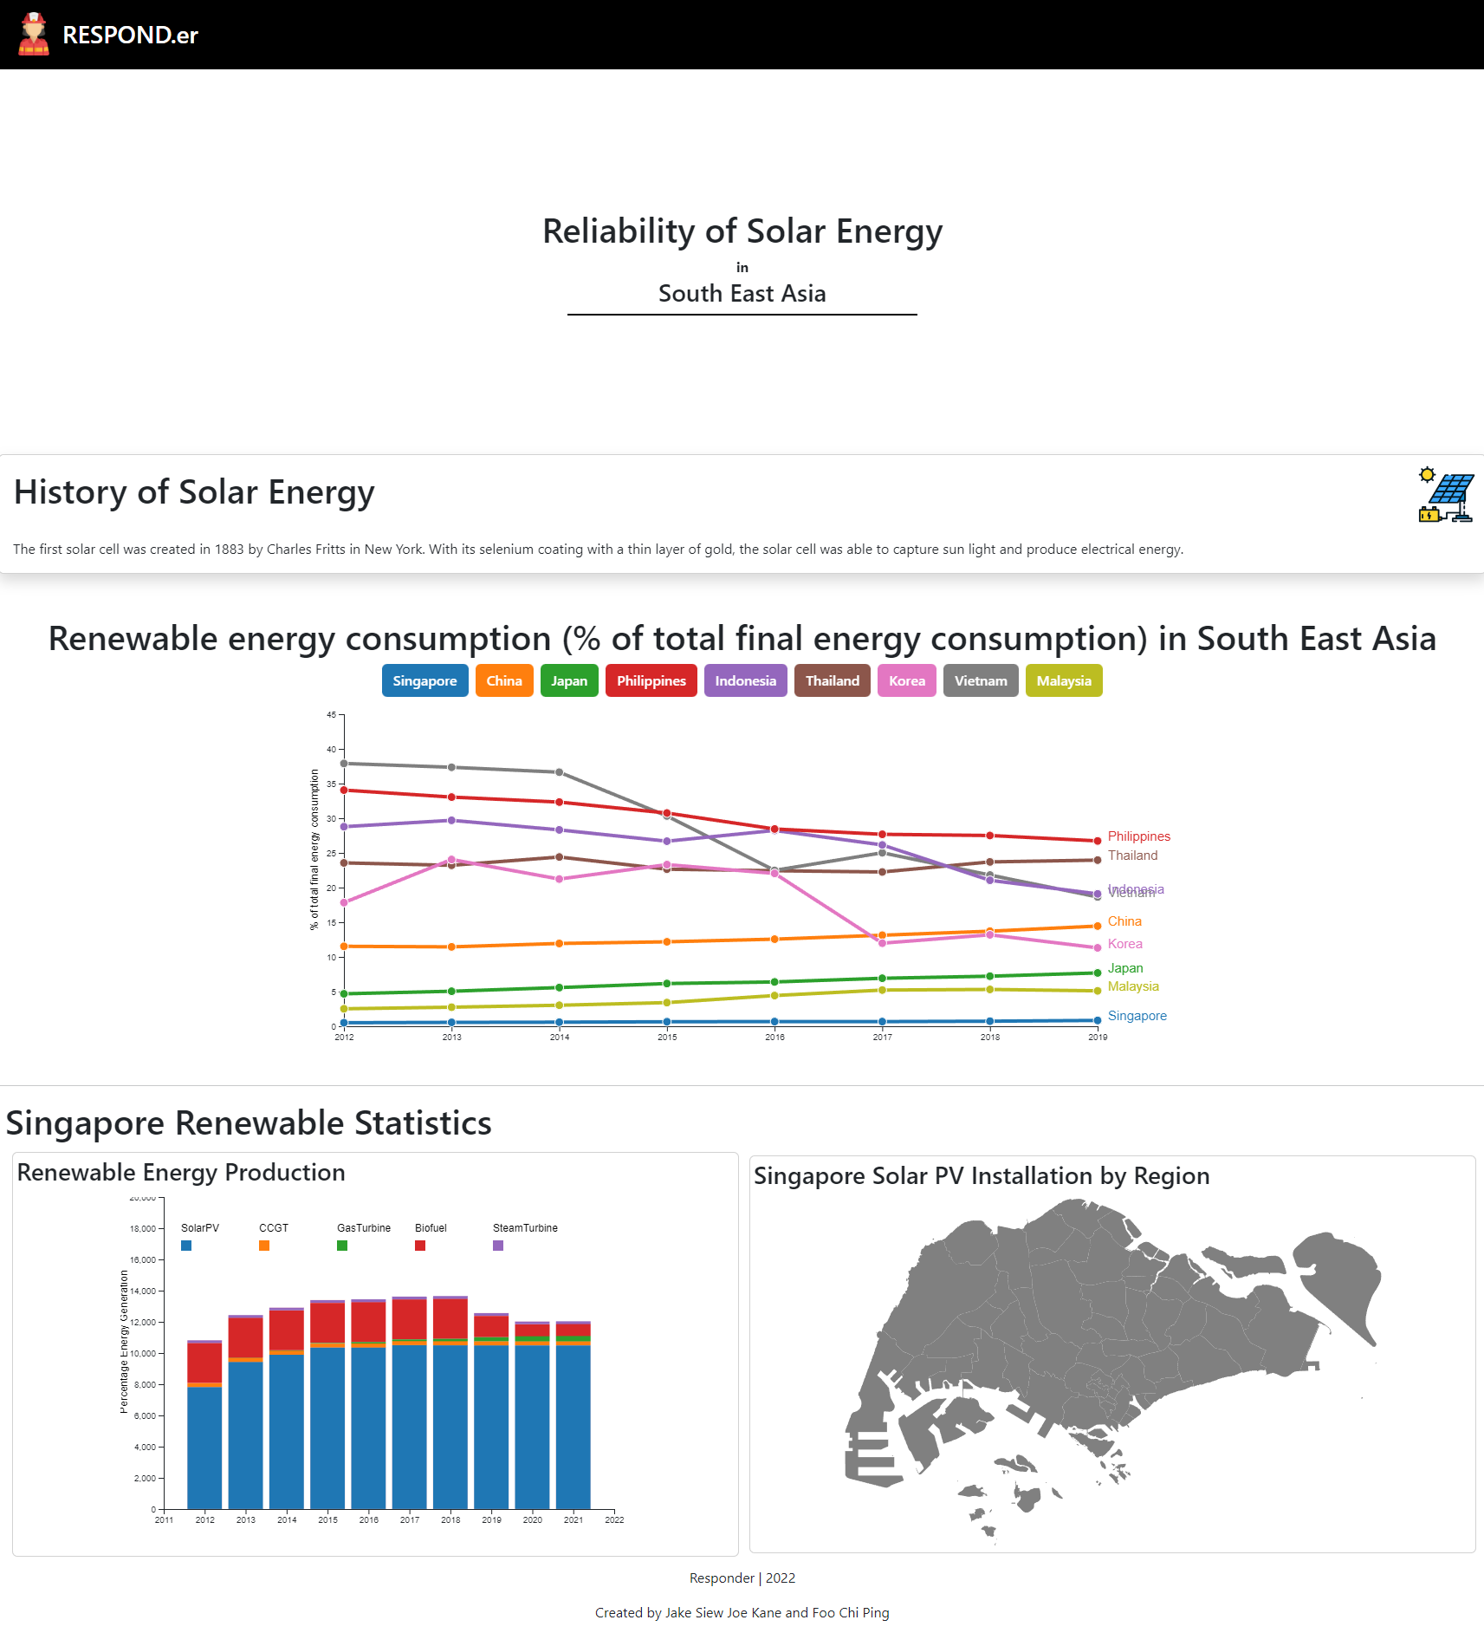

Figure 6

# 5 Validation [optional - Bonus Points]

Test your visualisation with users and report the results.

< insert comments >

# 6 Conclusion

Provide a summary of the project and what you learnt from doing it.

< insert comments >

# References

1. Murray, S. and O'reilly Media (2017). Interactive data visualization for the web : an introduction to designing with D3. Sebastopol, Ca I Pozostałe: O’reilly Media.
2. Ware, C. (2008). Visual thinking for design. Amsterdam: Morgan Kaufmann/Elsevier.